Changes document for MS Decom activities

Project: Z_i740_mat_mng

System : xFE, xEM

CD: 151938, **152048**

Transport request: DFEK962733, DFEK962652, DEMK931402

—---------------------------------------------------------------------------------------------------------------------------------

1. Adding a button for Export to my Drive in view.

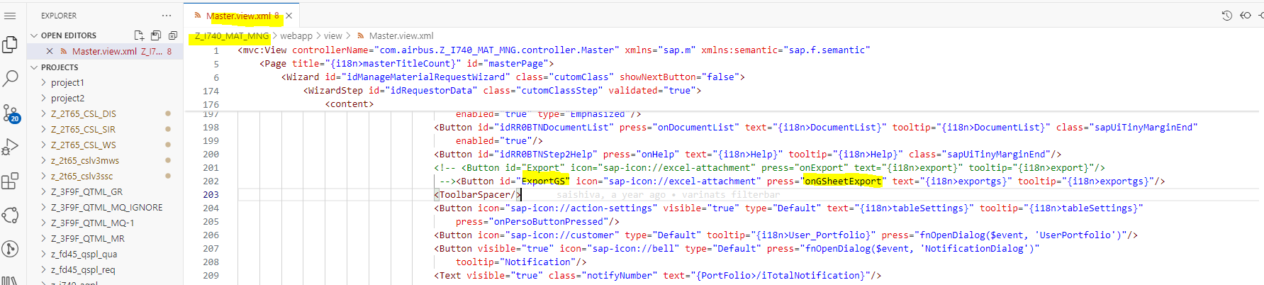

1. Below logic is on action of the button to call odata service entityset and fetch data.

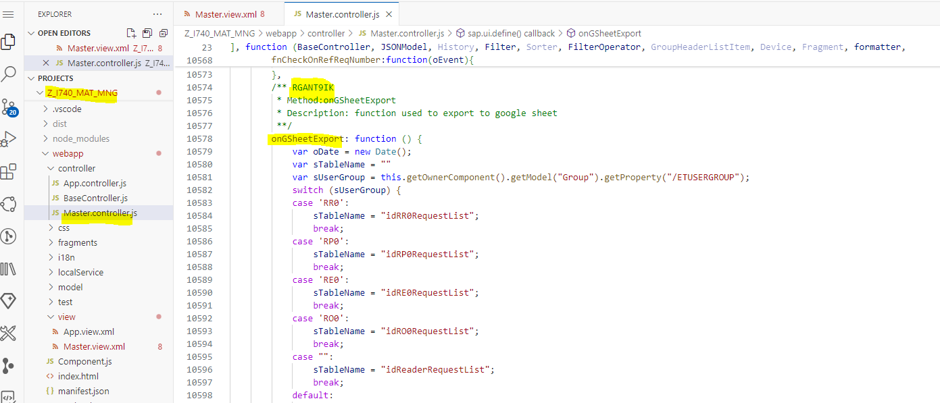

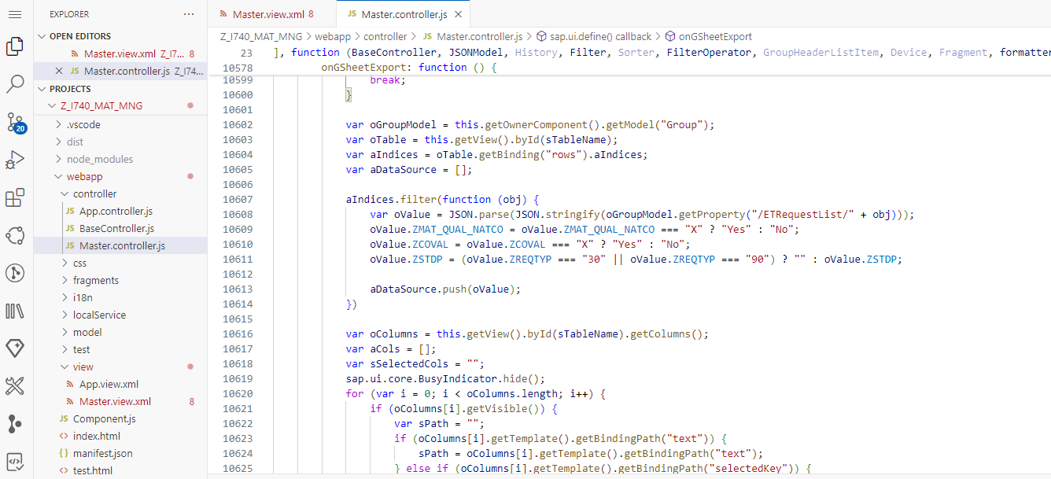

1. We are passing all the reqid’s as well as **MSDECOM** keyword in the PART field in filters to identify the flow is Export to my Drive action.

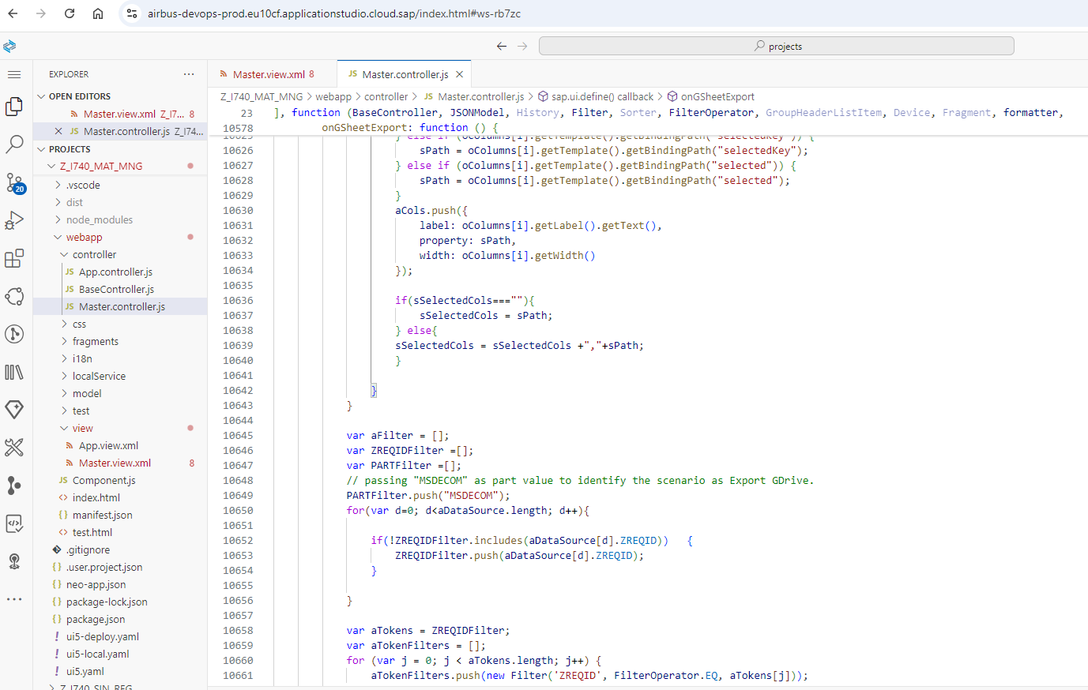

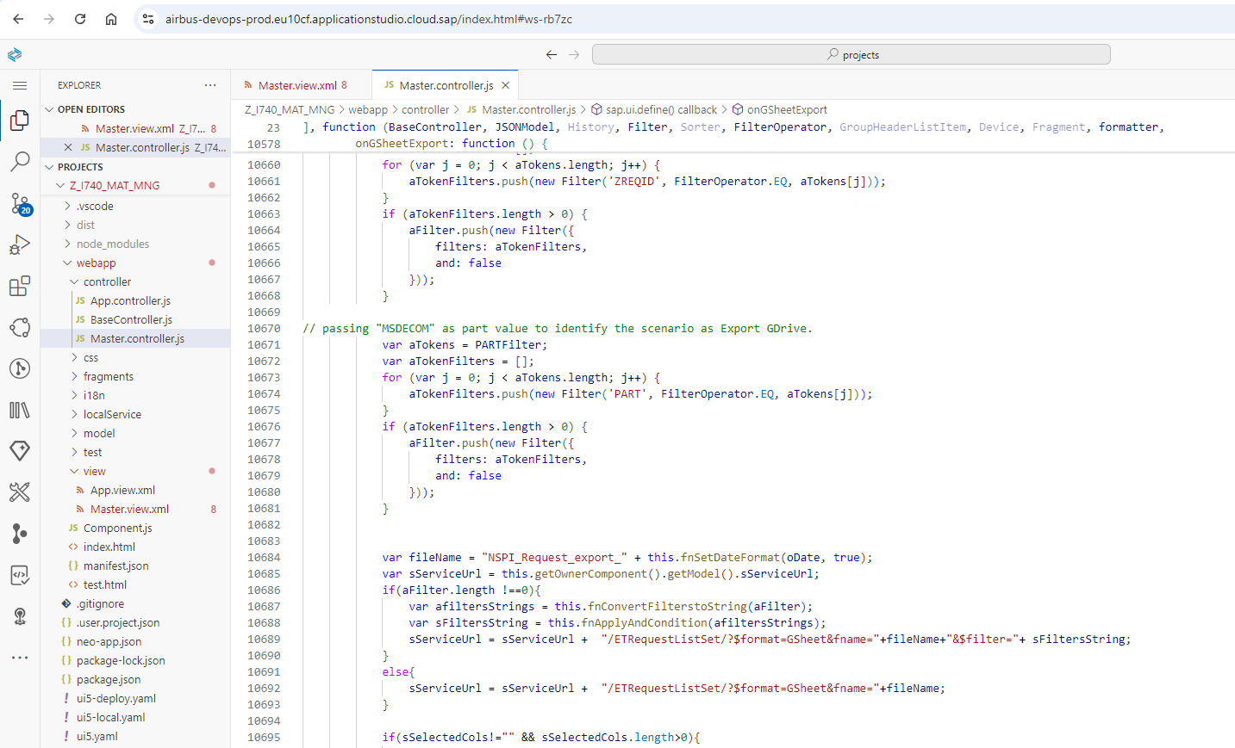

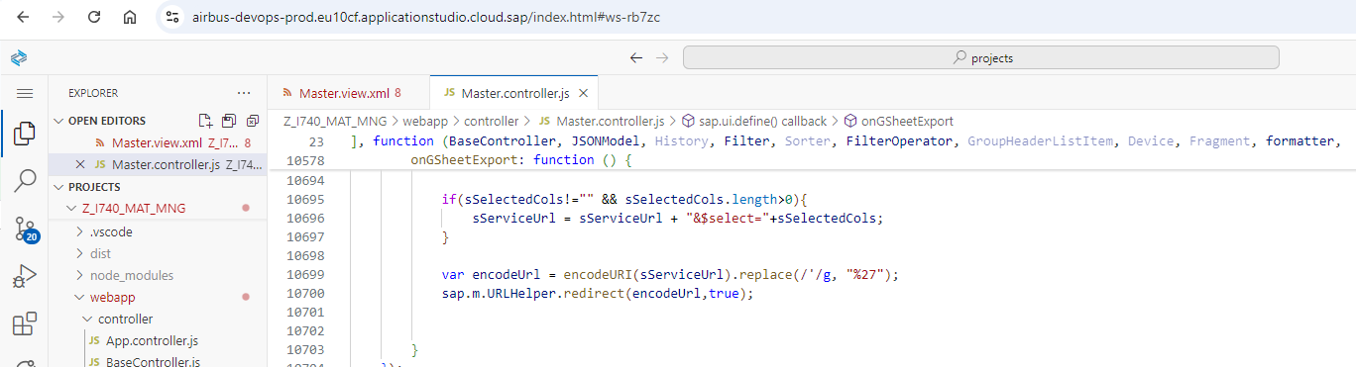

1. Changes in XFE - odata service DPC_EXT class method to read the REQID’s and fetch relevant records to export as google sheet.

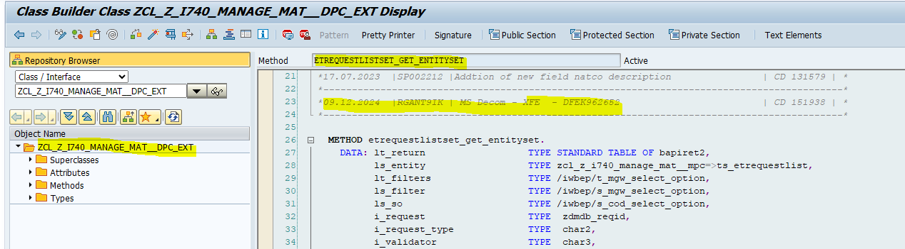

1. Populating the ET_ENTITYSET table to pass all the REQID’s to FM and fetch the records from XEM system.

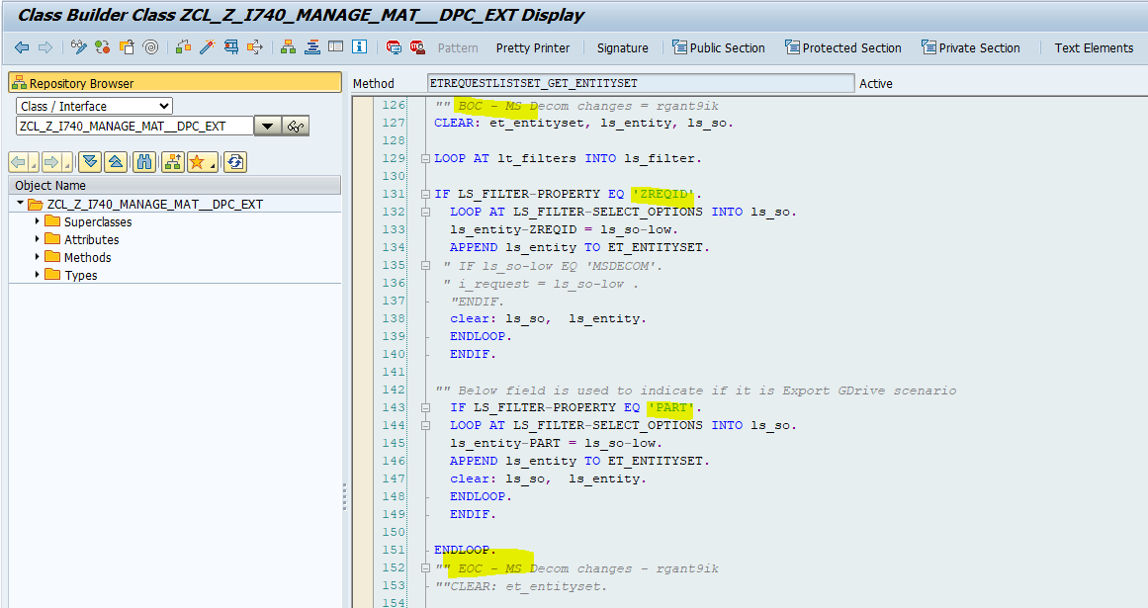

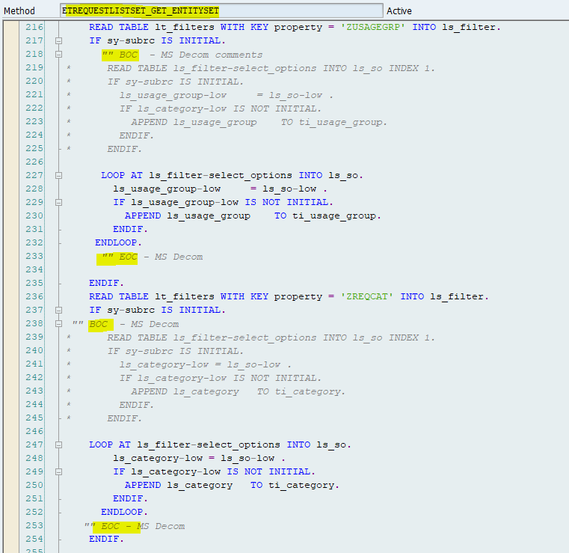

1. Below FM changes are in XEM system.

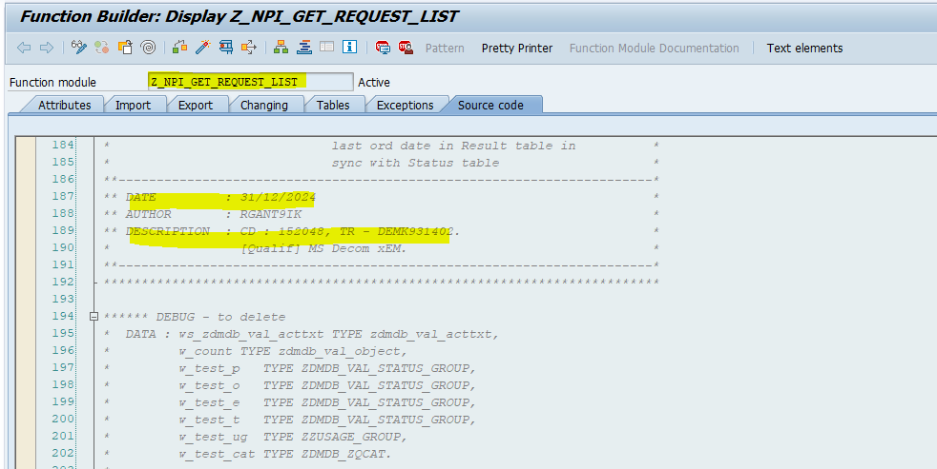

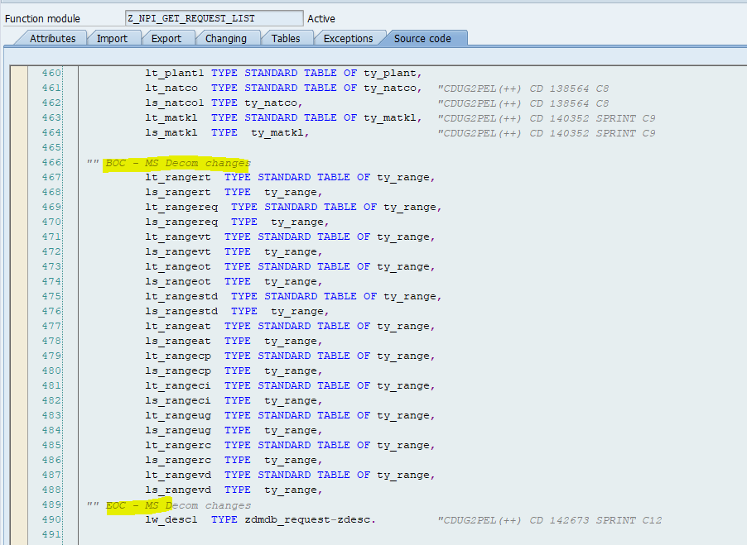

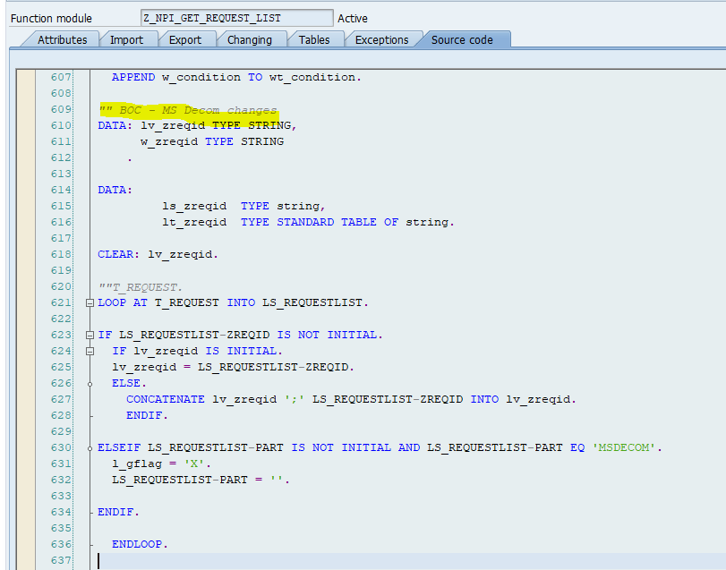

1. Below range table is created with the REQID’s to fetch only corresponding entries from zdmdb_request table.

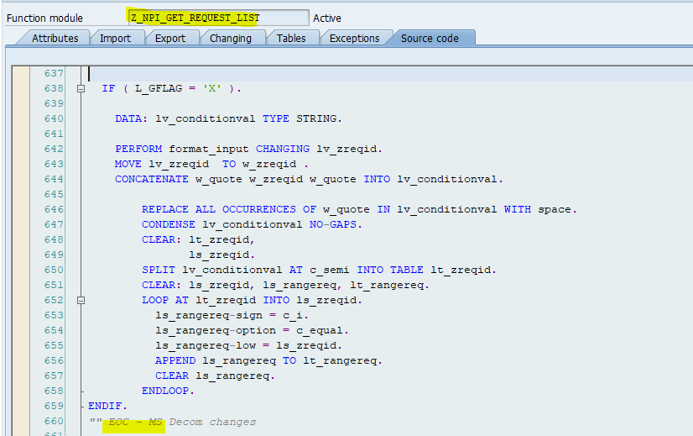

1. Below select query is to fetch the REQID details from zdbmdb_request table based on the above range table. This is the final details which will return into UI5 app and display the data in the form of google sheet.

